Cross-Border E-Commerce AI Tool Suite using the CrewAI framework.

High-Level Architecture Overview
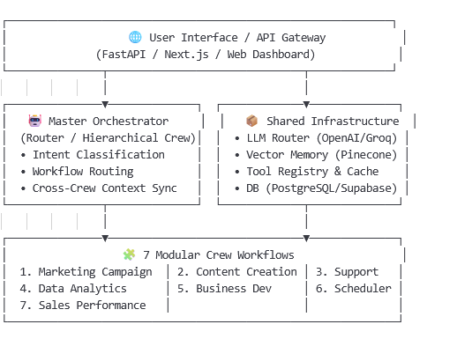

2. Workflow-by-Workflow Design (Agents, Tasks, Tools)

Online Marketing Campaign Workflow
Inspired by Tool1 + cross-border adaptations
- Agents: CampaignStrategist, AdCopywriter, ChannelOptimizer, ComplianceQA
- Tasks: Competitor/Keyword Research → Campaign Strategy → Multi-channel Ad Drafts → Regional Compliance & Tone Check
- Tools: SerperDevTool, MetaAds/GoogleAds API Wrapper, KeywordResearchTool, ComplianceCheckerTool (GDPR/CCPA/Ad Policies)
- Input: {target_market, product_category, budget, launch_date}
- Output: Structured campaign plan + ad creatives per region/channel

2️⃣ Content Creation Workflow
Directly aligns with Tool2
- Agents: TrendMonitor, MultilingualCopywriter, LocalizationSpecialist, ContentQA
- Tasks: Trend Scraping → Outline → Draft Generation → Translation/Cultural Adaptation → Brand Voice & SEO Review
- Tools: ScrapeWebsiteTool, DeepL/GoogleTranslate API, SEOptimizerTool, Pydantic Structured Output
- Input: {topic, target_languages, brand_guidelines}
- Output: Markdown article + localized social posts (ContentOutput Pydantic model)

3️⃣ Customer Support Workflow
Directly aligns with Tool3
- Agents: Tier1Support, EscalationSpecialist, QAAuditor, KnowledgeBaseUpdater
- Tasks: Ticket Triage → Order/Shipping Lookup → Resolution Draft → QA & Sentiment Check → KB Update
- Tools: Shopify/Amazon Order API, TicketingSystemTool, SentimentAnalysisTool, WebScraper, memory=True
- Input: {customer, inquiry, order_id, language}
- Output: Polished, localized response + ticket status update

4️⃣ Data Analytics & Research Workflow
Directly aligns with Tool4
- Agents: DataCollector, EcomAnalyst, MarketResearcher, ReportGenerator
- Tasks: Platform Data Extraction → Sales/Inventory/Ad Performance Analysis → Competitor Benchmarking → Dashboard/Report Generation
- Tools: PlatformAPITool (Shopify/Amazon/TikTok), CSV/DBReader, Trello/ProjectSyncTool, AnalyticsEngineTool
- Input: {date_range, metrics, region, board_id}
- Output: Analytical report + actionable insights + JSON/Markdown dashboard data

5️⃣ Business Development Workflow
Directly aligns with Tool5
- Agents: LeadProspector, PartnershipStrategist, OutreachSpecialist, CRMSyncAgent
- Tasks: Lead Profiling → Partnership Mapping → Personalized Email/Message Draft → CRM Logging & Follow-up Scheduling
- Tools: DirectoryReadTool, SerperDevTool, SentimentAnalysisTool, CRMIntegrationTool, memory=True
- Input: {lead_name, industry, decision_maker, milestone}
- Output: Lead profile report + outreach sequence + CRM sync payload

6️⃣ Event Scheduler Workflow (New)
- Agents: CalendarManager, TimezoneCoordinator, CampaignPlanner, ReminderAgent
- Tasks: Global Holiday/Event Mapping → Timezone-Optimized Scheduling → Resource/Deadline Allocation → Multi-Channel Reminders
- Tools: GoogleCalendarAPI, GlobalHolidayDB, TimezoneConverterTool, NotificationTool (Email/Slack/SMS)
- Input: {events, target_regions, campaign_deadlines, preferred_hours}
- Output: Optimized calendar export + notification schedule + conflict report

7️⃣ Sales Performance Improvement Workflow (New)
· Agents: SalesAuditor, CROSpecialist, PricingStrategist, PlaybookCoach
· Tasks: Funnel/Bottleneck Analysis → A/B Test Recommendations → Pricing/Discount Optimization → Sales Playbook Update
· Tools: CRMDataFetcher, CROHeuristicsEngine, DynamicPricingTool, FeedbackLoopTool
· Input: {sales_data, conversion_metrics, target_margin, region}
· Output: Optimization report + test matrix + updated playbook + implementation checklist

3. Shared Infrastructure & Cross-Cutting Concerns
Component | Implementation Strategy
LLM Router | Use langchain or custom router to assign tasks: gpt-4o-mini for drafting, groq/llama-3.3-70b for analysis, claude-3-haiku for cost-heavy loops
Memory | CrewAI memory=True for short-term context + Pinecone/Weaviate vector DB for cross-crew knowledge (customer history, brand guidelines, past campaigns)
Tool Registry | Centralize tools in tools/ folder. Use @tool decorator or BaseTool inheritance. Implement caching (functools.lru_cache or Redis) for API calls
Config Management | Keep config/agents.yaml & config/tasks.yaml per workflow. Use pydantic for strict input/output validation
Cross-Border Adaptations | • Multi-language routing  • Currency & tax calculators  • Regional compliance checkers  • Platform-specific adapters (Shopify, Amazon, AliExpress, TikTok Shop)
Guardrails | System prompts for "no hallucination", cite sources, fallback to human review, rate-limiting, PII redaction

- Recommendation Project Structure

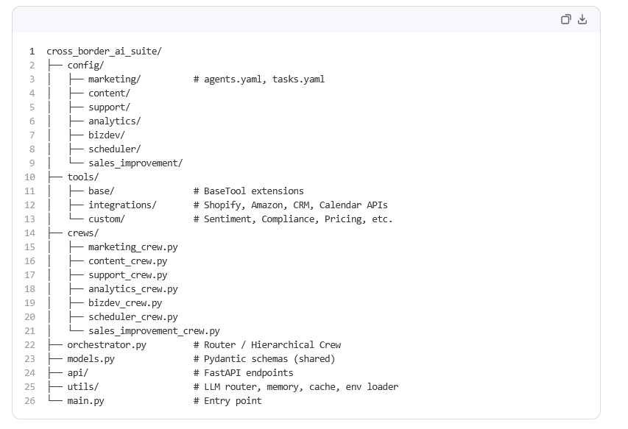

🚀 5. Implementation Roadmap & Best Practices
Phase | Deliverables
1. Foundation | Setup CrewAI, YAML configs, shared tools, LLM router, Pydantic models, env management
2. Core Crews | Implement Tool1-5 based crews first. Validate with mock inputs. Add memory=True where needed
3. New Workflows | Build Scheduler & Sales Performance crews. Integrate calendar/CRM/pricing tools
4. Orchestration | Create MasterCrew with Process.hierarchical. Route user intents → specific crews. Sync context via shared memory
5. API & UI | Wrap with FastAPI. Add async execution, job queues (Celery/Redis), webhook callbacks
6. Production | Add monitoring (LangSmith/PromptLayer), caching, rate limits, cost tracking, human-in-the-loop fallbacks

CrewAI-Specific Tips
- Use context=[task1, task2] to pass outputs between tasks within a crew.
- Prefer output_pydantic=YourModel for structured, parseable outputs.
- Set allow_delegation=True only when agents genuinely need to hand off (e.g., Support → QA).
- Use verbose=2 during dev, verbose=0 in production.
- Cache external API calls to avoid rate limits & reduce token costs.
- Store LLM usage metrics (crew.usage_metrics) for cost tracking per workflow.

Add the quene manager (Celery) and message broker ( Redis Cahce)
1. Project Structure
